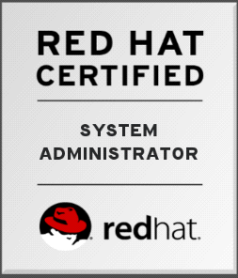
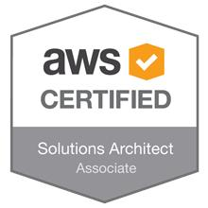

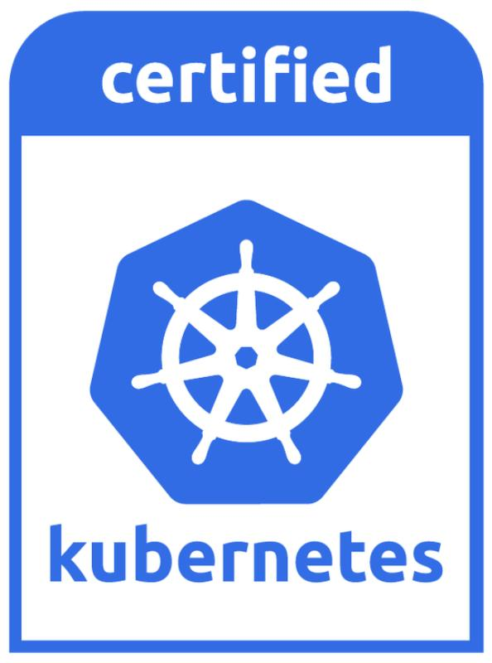
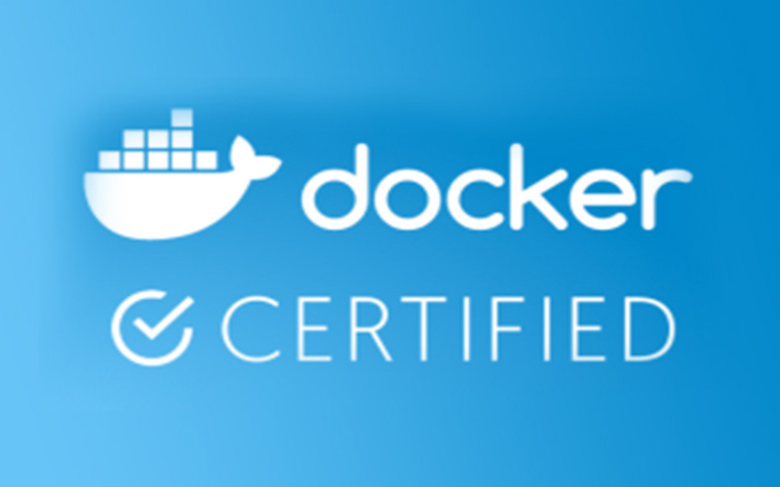
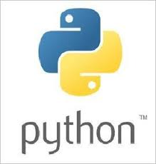

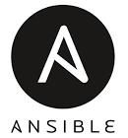



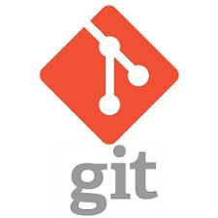
Rahman Khan, DevOps Engineer
Email: rahmanixed@outlook.com, Phone: +91-9976007426
--------------------------------------------------------------------------------------------------------------------------------------------------------------------------------------
Professional Summary

Red Hat Certified Engineer with technical and architectural expertise seeking for a challenging position where i can apply my domain expertise and interpersonal skills as a part of a team for the organizational development and increase my level of expertise and to learn new technologies.

Technical Skills:
- Cognitively expert in managing operating systems including:
- Red Hat Linux (RHEL) 6.0, 7.0
- CentOS 6, 7
-Technically competent with monitoring and ticketing tools:
- Nagios, Splunk & Grafna – Monitoring
- Service Now – Ticketing
-Knowledge of programming languages:
- Bourne Again Shell (BASH)Scripting
- SQL
- JSON
-Thorough with web application servers:
- Apache Tomcat,
-Adroit in utilizing security applications:
- SSH, SELinux
- Firewall, IPtables
-Technical Competent with Configuration management tool
- Chef
- Ansible
- Jenkins – CI/CD
-Conceptual Knowledge with:
- ITIL Foundation V3
- VMWare Virtualization
- AWS
Certification completed:
- RHCSA (Red Hat Certified System Administrator) 95%
- Certified AWS solution Architect

Professional Experience

Employer: Wipro Technologies
Duration: September 2018 to till date
Job Profile:
- Responsible to manage 2L + Windows and Linux servers with Data center Automation tool
- Server and Node configuration using Chef (linux) Bigfix (windows)
- Node and Date center server monitoring using splunk and Grafana
- Register new servers and re-register the unhealthy server based on the requirements
- Adding, Updating and removing attributes(JSON) on the node using Jenkins
- Removing orphans / Decommissioned nodes from chef server
- Changing servers owning group

Serve as System Administrator responsible for installation, system maintenance and troubleshooting of over 100 Red Hat Enterprise Linux servers, located multiple remote locations. Primary contact for system issues pertaining to system performance, initial troubleshooting and system maintenance supporting different time zones and across multiple geographic locations.

Designation: Linux System Administrator
Employer: Attenda Soft, Chennai
Client: Mediterranean Shipping Company, Switzerland
Duration: Dec 2015 – August 2018

Job Description
- Support assigned customer with customized RHEL configurations and troubleshooting through our global queue system.
- Address customer queries, assisting them in building out their infrastructure with our product offerings.
- Set up and administer user and groups accounts, setting permissions for users.
- Build and installed multiple Linux machines.
- System and Application troubleshooting and other related issues.
- Provided management of system process in areas like boot process, startup and system shutdown.
- Install, configure, maintain and administer Linux / UNIX operating systems and components. Diagnosed and resolved problems associated with NFS, SAMBA and Apache.
- Install and maintain Apache Tomcat Server, MySQL, Maria DB and Oracle Database servers.
- Maintain and support enterprise NetApp Storage Filer.
- Manage end user accounts, permissions, access rights, and storage allocations in accordance with best-practices regarding privacy, security, and regulatory compliance, as defined
- Cron and AT job scheduling and monitoring
- Planned and executed packages and updates installations necessary for optimal system performance.
- Assists in Architect virtualization-based solutions
- Develop, update and maintain Standard Operating Procedures (SOP) documentation.
- Resolve troubleshooting problems and issues relating system infrastructure with logical action.
- Track and work on outstanding Incidents and Problems through ticketing system.

Academic Qualification

Degree and Year of Passing | Major and Specialization | Institute | YOP
Bachelor of Business  Administration (Distance) | Business Administration | Alagappa University | 2017
Diploma in Mechanical Engineering | Mechanical Engineering | Saisha institute of Technical science | 2012

Personal Details

Date of Birth | 12-May-1992
Nationality | Indian

Declaration: I hereby declare that the information furnished above is true to the best of my knowledge.

Rahman Khan Place : Chennai

